**Six Sigma Project Charter**

**Business Case:**  
Business case helps to understand how the project is linked with the overall business objectives. Business case explains why there is a need for the organization to undertake the project and how it will support organizational objectives.  
  
The business case should be able to answer the following questions:

* Why is the project **worth doing?** Justify the resources necessary to engage in the project.
* Why is it **important to customers?**
* Why is it important to the **business?**
* Why is it important to **employees?**
* Why is it important to **do it now?**
* What are the **consequences of not doing** the project now?
* How does it **fit with the operational initiatives and targets?**

Business Case Example:  
“By reducing the average transaction length, the queue would be able to enhance the Speed of Resolution and assist the end-users in fastest possible manner. This will not only help in achieving client targets but also increase end-user satisfaction score by offering lesser turn-around time.”  
  
**Problem Statement:**  
Problem statement should quantitatively describe the pain in the current process

* What is the pain ?
* Where is it hurting?
* When – is it current? How long it has been?
* What is the extent of the pain?

What a Problem Statement should not do is Assign a Cause or Blame and Include a Solution.  
  
Problem Statement Example:  
“In the last 3 months**(when)**, 12% of our customers are late, by over 45 days in paying their bills **(what)**. This represents 20% **(magnitude)**of our outstanding receivables & negatively affects our operating cash flow **(consequence)**.”  
  
**Goal Statement:**  
Defines the improvement the team is seeking to accomplish. It starts with a verb. It Should not presume a cause or include a solution. It has a deadline. It is actionable and sets the focus. It should be SMART (Specific, Measurable, Attainable, Relevant and Time Bound).  
  
Goal Statement Example: To reduce the percentage of late payments to 15% in next 3 months, and give tangible savings of 500KUSD/ year.  
  
**Project Scope:**  
Project Scope helps us to understand the start and end point for the process and also gives an insight on project constraints and dimensions. It’s an attempt to define what will be covered in the project deliverables. Scoping sharpens the focus of the project team & sets the expectations right. There are two types of scoping:

* Longitudinal Scoping
* Lateral Scoping

Absence of proper scoping may result in the team **losing interest** in the project. Project becomes **difficult to implement**. Even after implementation, the **desired benefits are not seen.** Team focuses on trivial pain areas, and **missing out the real ones.**Process selected is **too broad to handle.**  
  
**Longitudinal Scoping:** Longitudinal scoping is done on the length of the process  
e.g. – From the receipt of PO till the delivery at the distributor's go-down  
e.g. – From the time of customer reporting the complaint till final satisfaction confirmation  
Mostly the ‘start’ & ‘end’ points are fixed. A macro as-is process map must be prepared to facilitate longitudinal scoping.  
  
**Lateral Scoping** is done on the breadth of the process  
e.g. – All despatches from North & South regions  
e.g. – Calls received during general shift  
  
By using Longitudinal and Lateral Scoping methods, we know what all kinds of units the process will cover, in what situations the process is valid, what are the qualifiers for the transactions, what functional domains does the process cover and in what geographical areas the process is valid.  
  
Scoping Example:  
Longitudinal Scope: The time when the Sourcing team receives the resume of a referral or the time when a candidate walks in to organization premises for an interview and joins the organization.  
  
Lateral Scope: Candidates interviewed till Senior Manager level across the organization, all locations.  
  
**Project Milestones:**  
Project milestone in a charter specifies timelines for completion of each phases with signed tollgates. It is a preliminary, high level project plan with dates, which is tied to phases of DMAIC process. It should be aggressive (don’t miss “Window of Opportunity”) yet should be realistic (don’t force yourselves into “Band-aid” solution). The project milestones to further include a detailed project plan (Gantt chart) along with a documented communication plan.  
  
**Specification Limits:**  
A specification is a customer-defined tolerance for the output unit characteristics. There may be two-sided specifications – Upper Specification Limit (USL) and Lower Specification Limit (LSL). Any data point above the USL and below LSL is termed as defect. Specifications form the basis of any defect measurement exercise on continuous data.

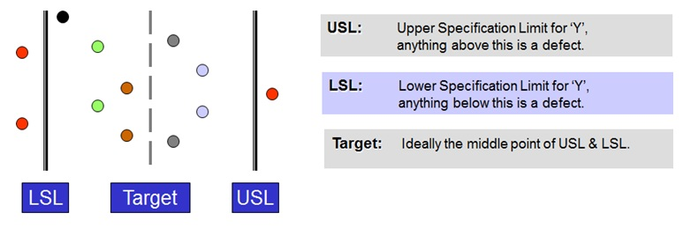  
**Six Sigma Process Specification Limits**

Specification limits should follow the RUMBA acronym. RUMBA stands for Reasonable, Understandable, Measurable, Believable and Attainable.  
  
**Reasonable:** The specification based on a realistic assessment of customer’s actual needs. We need to check if the specification relate directly to the performance of the characteristic.  
**Understandable:**The specification is clearly stated and defined so that no one can misinterpret it.  
**Measurable:**We should be able to measure the characteristic’s performance against the specification. If not, a lot of debate will ensue between you and your customer as to whether the specification has been met.  
**Believable:**We should have bought into the specification setting. That is, we and our teams should strive to meet the specification.  
**Attainable or Achievable:**We should be able to reach the level and range of the specification.  
  
**Resources and Team Roles:**  
Ultimately executive leadership team together with Six Sigma Deployment Leader and Six Sigma Champion need to ensure that a trained Six Sigma Team and associated hardware and software resources are in place to successfully implement the Six Sigma project and deliver great results and customer value!